FORMATTING OUTPUT
When you output data to the screen in python you might find that you would like to format this data so that it has a nice, readable look.
There are some special ways to do this.

\n
New Line
When you output text to the screen you can use the \n character to jump to a new line.
Try this code:
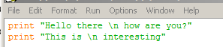

\t
Tab
When you output text to the screen you can use the \t character to leave a tab.
Try this code:
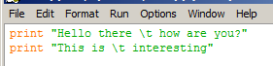

.center
Center Text
You can center a line of text within a set number of spaces.
At the end of your output line you simply add .center and then the number of spaces, like (40)
Try this code:
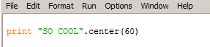

You can also add a character to fill in the blank spaces.
Try this code:
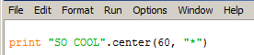

.ljust .rjust
Left and Right Justifying Text
You can left and right justify text so that it lines up against the left margin or right margin of the output screen.
Try this code:
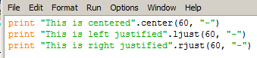

FORMATTING OUTPUT

Type the following code into python and write down the output:
print "I", "love", "programming"
print "I" + "love" + "programming"
print "I".ljust(15), "love".center(15), "programming".rjust(15)
print "I".ljust(15,"*"), "love".center(15,"*"), "programming".rjust(15,"*")
print "Nice Table".center(24)
print "Name".rjust(8),"Age".rjust(8),"Sex".rjust(8)
print "----".rjust(8),"---".rjust(8),"---".rjust(8)
print "James".rjust(8),"22".rjust(8),"Male".rjust(8)
print "Beth".rjust(8),"6".rjust(8),"Female".rjust(8)

- Write a program that prints out the top ten of any category. There must be at least three columns of information. Include headings at the top of each column. The information in the columns must line up. Use the \t character in the print statement to line up the columns. The output of your program could look as follows:
Top Ten Soccer Teams
====================
RANK TEAM Points
---- ---- ------
1 Spain 1564
2 Netherlands 1365
3 Germany 1345
4 Uruguay 1309
5 England 1173

- Write a program that ouptuts a menu to the screen using .center, .ljust and .rjust.
The output from your program should resemble the following:
