!!!CALCULATING STUFF!!!
One of the greatest things you can do in computer programming is calculating. Seriously. It’s awesome.
Take a look at the code below, it asks the user to enter the length and width of a rectangle, and then outputs the area:
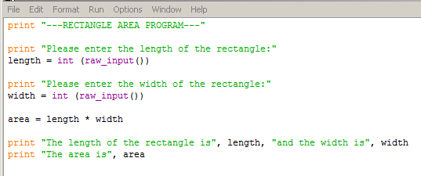
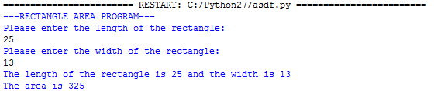
Try to create the following programs:
- A program that prompts the user for three numbers, then adds them all up and outputs the answer.
- A program that prompts the user for 2 numbers, multiplies them, and then outputs the number.
- A program that prompts the user for a price of an item, then outputs the total price with 13% tax added.
- A program that prompts the user for their age, then asks them the number of days since their last birthday. The program the outputs how many days they have been alive.
- A program that prompts the user for the base and height of a triangle, then outputs the area of the triangle.
- A program that prompts the user for four course marks, then outputs their average.
You will need to figure out what data needs to be entered in by the user for the next ones:
- A program that calculates and outputs the area of a circle based on data given by the user.
- A program that calculates and outputs the volume of a cube.
- A program that calculates the speed in km/h of a runner in a 100 m race.
- A program that calculates the volume of a rectangular prism.
Now it’s time to get creative. Think of a program that you would like to write that involves calculating something that people need to know quite frequently. Imagine it sort of as an app.
Create that program.
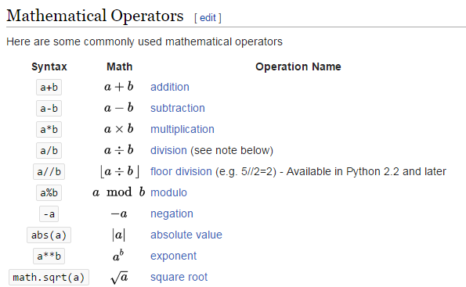
You might need this for the programs above:

