Receiving Input From the User
So far the programs that you have written have all used data that was set up within the program.
It is possible to write programs that actually receive data that is typed on the keyboard by the user.
The code to receive data from the user is raw_input()
When you get the data from the keyboard you have to specify what kinds of data it is.
Python Data Types
You can get three types of data from the user:
An integer: a positive or negative number that does not have decimals
A float: a positive or negative number that has decimals
A string: a series of letters or characters
Take a close look at the program below, it asks the user for their age (which is an integer), their weight in kilograms (which is a float) and their name (which is a string):
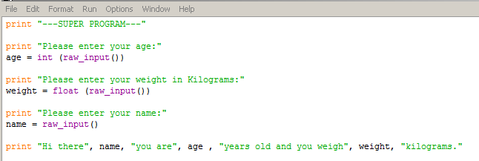
To read in an integer you need to indicate the name of the variable, then an equals sign, then int (raw_input())
For example: age = int (raw_input())
To read in a float you need to indicate the name of the variable, then an equals sign, then float (raw_input())
For example: weight = float (raw_input())
To read in a string you need to indicate the name of the variable, then an equals sign, then raw_input()
For example: name = raw_input()

Fill in the code below:

A programmer wants to read in the age of a person, it won’t have decimals.
They wrote the code age = _________________________
Fill in the blank line with the code that goes next

A programmer wants to read in distance to Toronto, it will have decimals.
They wrote the code distance = _________________________
Fill in the blank line with the code that goes next

A programmer wants to read in the name of the current month
They wrote the code month = _________________________
Fill in the blank line with the code that goes next

Imagine you wanted to read in the following data from the keyboard, what line of code would you have to use? The first three have been done for you.

You should make up a name for the variable that describes what you are storing (for example if you are storing the person’s age then call it age, etc…)
The current temperature, with no decimals | temp = int (raw_input())
The name of this school | schoolName = raw_input()
Your class average, which will have decimals | avg = float (raw_input())
The number of people in your class
The name of your favourite basketball team
The price of a pair of shoes
The distance from London, On to Vancouver, BC with decimals
The name of a famous hockey player
The number of chocolate bars in a box
The number of pencils in a drawer
The air pressure at 1kms above the earth, with decimals
The price of a video game, with decimals
The name of the user’s favourite technology company
The name of your favourite band
The percentage of taxes paid, with decimals
The interest on a loan, with decimals
The number of pages in a book

Your task is to now open python and recreate the age, weight and name program on the other side of the page.
When complete, try to write the following programs:
- A program that asks the user for their name, their class average (with decimals) and the number of courses they are taking. The program will then output a message like:
Hello Jen, you are taking 3 courses and your class average is 79.8%
- A program that asks the user for their school name, the number of kms between school and their house (with decimals) and then outputs a message like:
Hello Eric, your school is called CCH and it is 5.7 kms from your house.
- A program that asks the user to enter two numbers (no decimals).
The program then outputs the message:
You chose 6 and 9
Added together they make: 15
Multiplied they make: 54

