Python
Name: _________________________
Understanding Variables and the Math Object

Create a program that includes the following seven lines at the top:

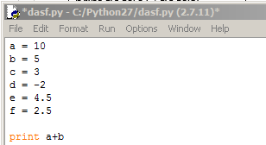
When you run the program the number “15” will be outputted to the screen.
Change the equation to a-b. Guess the output in the table below and then write down the actual output. Do this for all of the statements - guess first then alter the code and run the program.

Statement | Your Guessed Output | Actual Output
print a + b | 15 | 15
print a - b

print a * b

print a / b

print a / c

print a // c

print c / d

print float(c) / float (d)

print int(e) / int (f)

print float(e) / float(f)

print a % b

print a % c

print a % d

print b % c

print (a*b) % c

print (a-b+c) % c

print (3*b-a) % c

print math.sqrt(5 * b)

print math.pow(b,2)

print b**3

print math.pow(d,c)

print d**c

print d – c + f / 2.5

print (8 * d – 2 * e) // 3

print (4 * b – 12) / (e * f)

