PYTHON PROGRAMMING
- Open python from the Windows Programs area on the computer
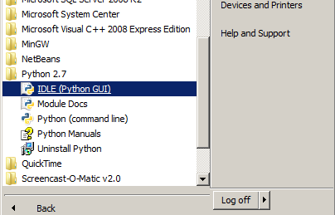

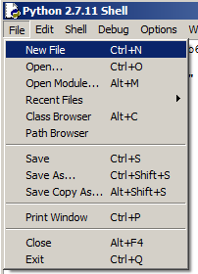
- Click File… New File…

3. In the blank window type the following:
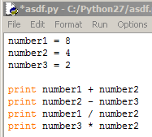

4. Click File… Save As and save your program as Python1
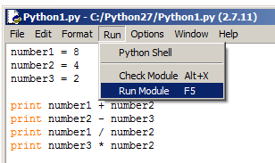
5. Click Run and then Run Module or just press F5:

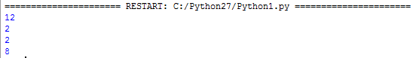
6. You should see the following on the screen, this is the output from your program:

7. Now it is time to write some new code:
Create a program that:
-creates a variable called num1 that is equal to 4
-creates a variable called num2 that is equal to 7
-creates a variable called num3 that is equal to 12
-prints the equation num1 + num3
-prints the equation num3-num2
-prints the equation num3 * num2 * num1

Your code should look like this:
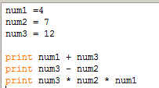

Run your program and record the output here:

8. Now it is time to create another program:
Create a program that:
-creates a variable called length that is equal to 5
-creates a variable called width that is equal to 7
-creates a variable called area that is equal to length * width
-prints the variable area to the screen (print area)

Run your program and record the output here:

9. Now it is time to create another program:
Create a program that:
-creates a variable called base equal to 8 and a variable called height equal to 9
-creates a variable called area that is equal to base times height divided by 2
-prints the variable area to the screen (print area)

Run your program and record the output here:

